# Group Report Weeks 6 – 10

Group name: Goku

Group Members: Aidan Willis, James Sadler

## Assigned Tasks

James: Gantt Chart

Aidan: Resource Chart

## James

### Week 5

Both me and Aidan both decided to work on other assignments for other courses as we were getting slightly behind schedule. This would have a lot of issues in the future if we didn’t work on them now, so we had to put this course on standby for a while as we caught up with everything else.

### Week 6

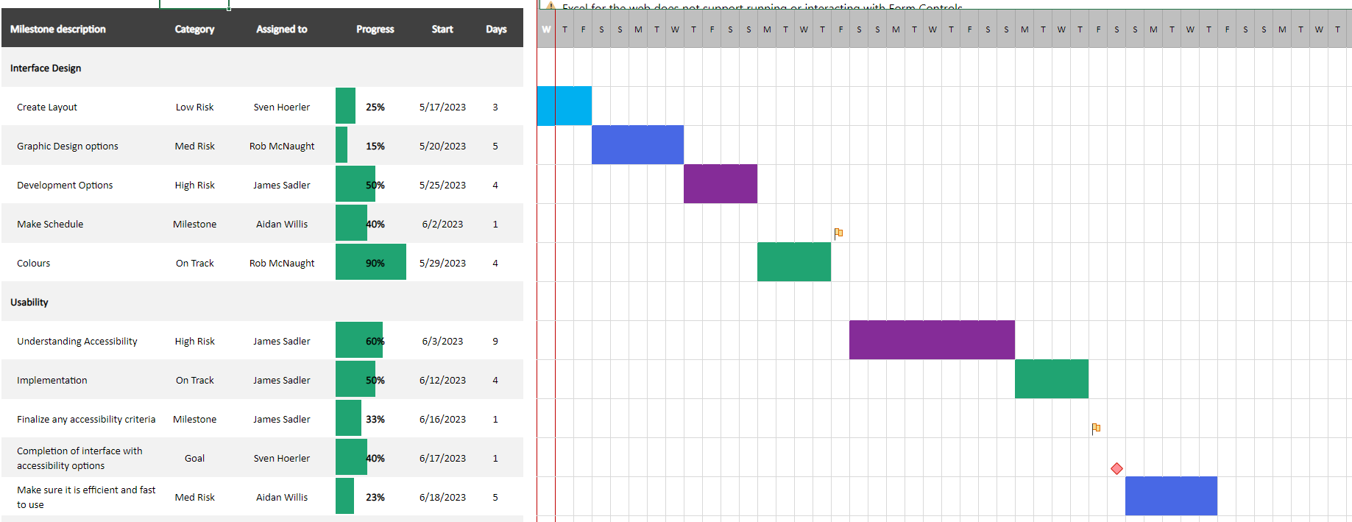

This is the Gantt chart that I created from the template provided. This took a decent bit of figuring out as I wasn’t initially certain what I needed to add to this. I gave it my best shot without both the iteration one and two meeting reports done but this was a challenge to figure out.

Week 7

For this week I primarily kept working on the Gantt chart figuring out what milestone, date, progress and the risk type for the milestone. After finishing the meeting report this became a lot easier as I at least had a vague idea of what was meant to go into the chart.

### Week 8

These weeks I continued working on other courses assessments. The UX/UI assessment was upcoming and was taking all my attention for the time being. I still found time to communicate issues and deadlines with Aidan so we could both direct attention to the UX/UI assessment.

## Week 9

This final week I finished the Gantt chart with everything required. This includes all milestones and requirements, such as the risk of all of the milestones, the name and the deadlines for them. This was a challenge to get through as it required a lot of thinking about what would be required

Aidan

### Week 5

With this week since we just uploaded iteration 1 James and I decide to take a break and focus on some of our other classes and their assignments would

### Week 6

This week me and James decided who would do what file and how much work, so we chose for James to do the Gantt chart since he knew a lot about Excel, and I would be happy to do two files, and if he needs help uploading the data on to any of the other

### Week 7

With week 7 and the deadline approaching I got a start on the table with adding some of the tables giving more fleshed-out detail

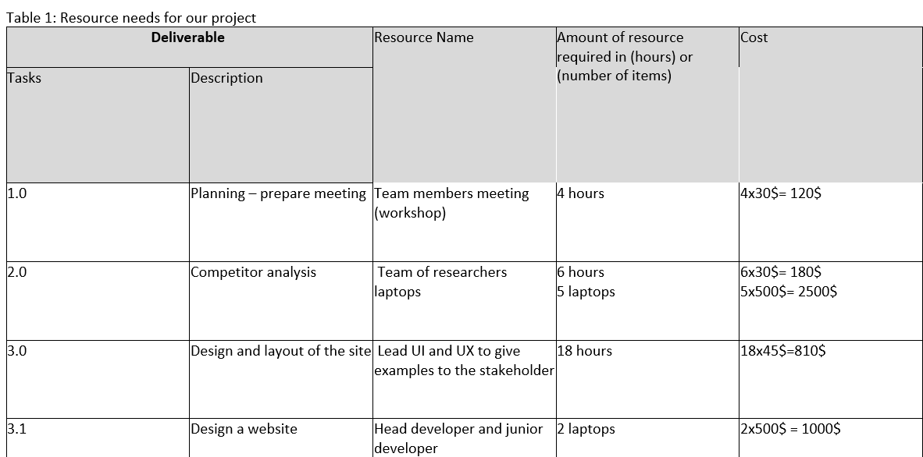

I waited for some of the gantt chart to be done so I could input some of the data on the table.

### Week 8

This week Noor help convert last week meeting report into this wee week's meeting report and all I need to do is change some dates and names and finished the resource report 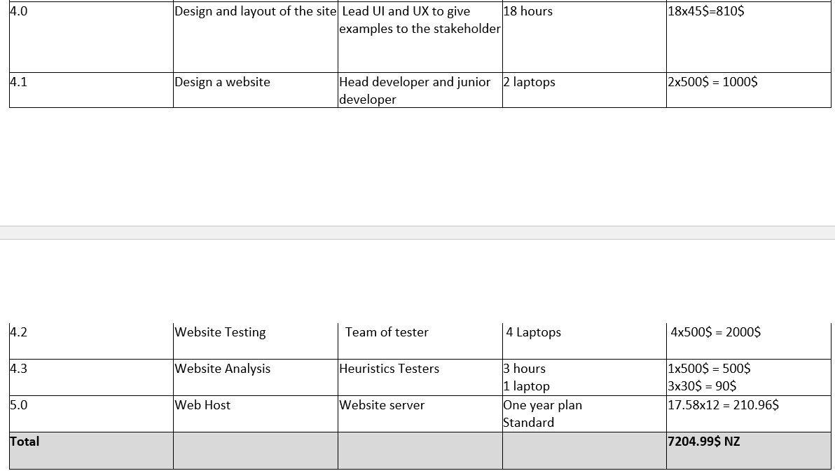

## Group Issues

### Issues we’ve come across

With the semester ending all lot of deadlines need to be met so the first week me and James focused on our other assessments, especially with UX/UI as this one was in the middle of the work time for this assessment.

### Issues dealt with and how we fixed them

We dealt with this issue by stopping working on this course temporarily and working on the other courses due. This kept us up to date with the other courses as well as this one.

### Challenges

Grammar: As we were slightly stressed with working on the other courses, our grammar degraded quite noticeably, we had less time to work on this iteration compared to the first one.

Time: With the UX/UI assessment being due halfway into this assessment we had to work out how to get both assessments done

Motivation: Approaching deadlines made us stressed that we hadn’t finished this assignment. This gave us the motivation to get it done.

### Achievements

We didn’t really achieve much honestly. We just got it done.